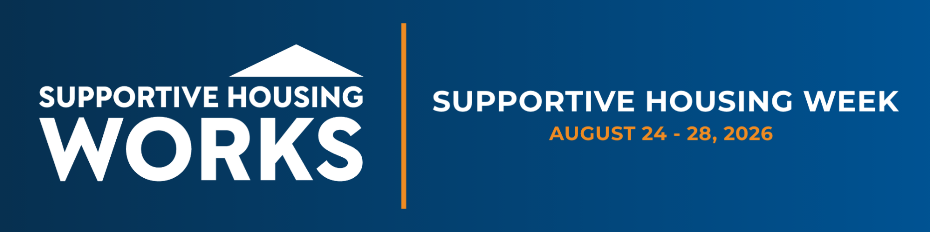

FOR IMMEDIATE RELEASE
[Official or Community Leader Name] Tours [Site Name], Sees Supportive Housing at Work for Individuals with Disabilities
Visit highlights a solution that helps residents stay housed and saves communities money
[City, State] — [Date] — [Organization] welcomed [Official or Community Leader Name] to [Site Name] on [Date] for a tour during Supportive Housing Week, the national effort led by the Corporation for Supportive Housing to show members of Congress how supportive housing works in their districts. [Official or Community Leader Name] met residents, toured units, and spoke with staff about how the program connects people to stable housing and the services they need to keep it.
Supportive housing combines an affordable home with support services tailored to each resident. It is the most effective and cost-effective tools communities have helping individuals with disabilities who are homelessness get housed and stay housed. It works because it replaces expensive, repeated crisis responses with a stable solution
The cost case is well documented. The data shows participants in supportive housing cost local systems $6,876 less per person each year than people who cycled through jail or used emergency services. Reviews of supportive housing programs found that 70 to 90 percent of participants stay stably housed two to three years after placement compared with 30 to 50 percent in treatment-first programs.
In [City/region], [Organization] serves [number] residents across [number] units. “For years we watched the same people cycle through our emergency rooms, our shelters, and our jails, and nothing changed,” said [Official or Community Leader Name]. “Supportive housing changed that. When someone has a stable home and someone to call for help, the crises stop and the costs that came with them stop too.”
“Supportive housing works because it treats the root of the problem, not just the symptoms,” [another person] said. “The evidence is clear. We are grateful to [Official or Community Leader Name] for taking the time to see firsthand what works in [City/region].”
[Organization] joined supportive housing providers across the country in opening their doors to local officials and community leaders during Supportive Housing Week. [Closing sentence on next steps, such as an invitation to stay engaged or a thank you to attendees.]

About [Organization]
[One paragraph of partner boilerplate.]

About CSH
The Corporation for Supportive Housing is a national nonprofit that helps communities create permanent supportive housing to end homelessness and strengthen local systems. Learn more at csh.org.

Contact: [Name], [Title], [Organization] | [Phone] | [Email]

###

