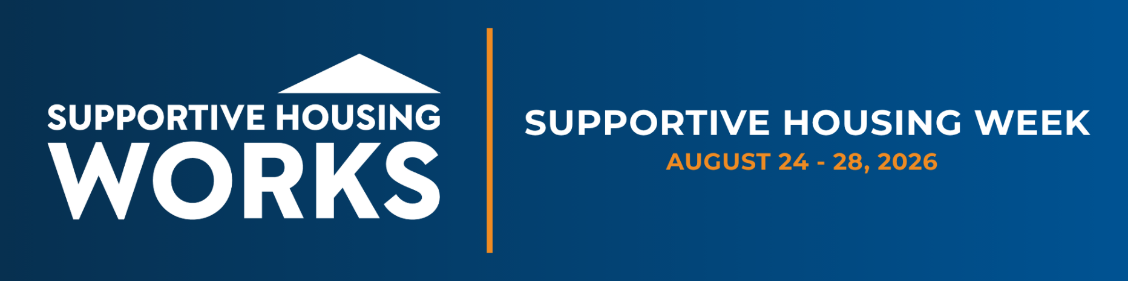

MEDIA ADVISORY
[Local Organization] to Show [Lawmakers] How Supportive Housing Helps People with Disabilities Break the Cycle of Homelessness
[City, State] — [Organization] will host [Official or Community Leader Name] for a tour of [Site Name] on [Date] as part of Supportive Housing Week, a national effort to show members of Congress how supportive housing works in their own communities. Members of the press are invited to attend.
Supportive housing reduces helps people with disabilities get housed and stay housed and costs communities less than the cycle of emergency rooms, shelters, and jails it replaces. The tour will provide [Official or Community Leader Name] a firsthand look at how stable housing paired with on-site services helps residents rebuild their lives while easing the strain on local public systems.
WHO
[Official or Community Leader Name], [Title, Jurisdiction]
[Executive Director Name], [Organization]
[Resident or staff names available for interviews, optional]
WHAT
A guided tour of [Site Name], followed by a brief conversation with staff and residents about how supportive housing serves formerly homeless people with disabilities in [City/region].
WHEN
[Day, Date], [Start Time] to [End Time]
WHERE
[Site Name], [Street Address], [City, State]
WHY
Supportive Housing Week runs August 24 through August 28. The visit will permit [Official or Community Leader Name] to see a proven, cost-effective solution in action and hear directly from the people it serves.
RSVP: Press who plan to attend should contact [Name] at [Phone] or [Email] by [RSVP Date]. [Note any access, parking, or photo and video guidance.]

###

