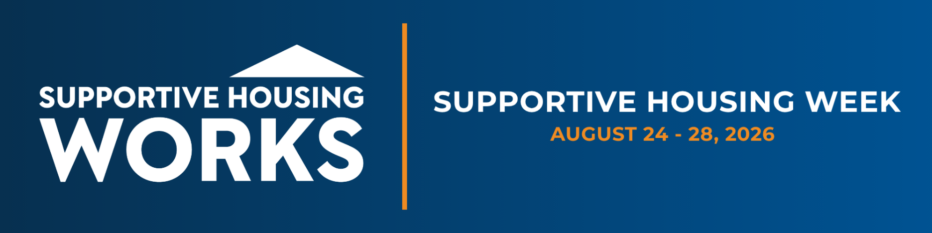

HOW TO USE THIS TEMPLATE

Use the template provided to create materials tailored to your organization and community.
- Replace all [bracketed text] and (parenthetical text) with information specific to your organization, program, community, or state.
- Look for ► guidance notes, which provide instructions on what information to include.
- Replace any yellow highlighted sample text with your own content. Sample text is provided for illustration only and should not be included in your final materials.
- Remove all guidance notes, placeholder text, and instructions before finalizing your documents.
- Feel free to adjust formatting, length, photos, graphics, and branding to align with your organization's style.
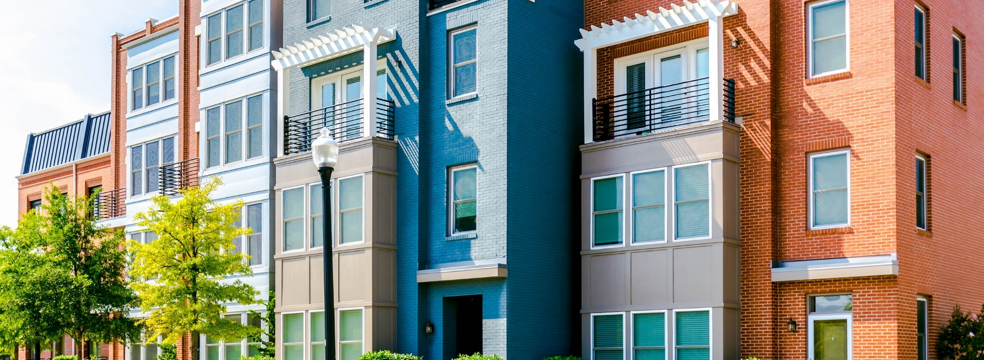
[Insert Your
Agency Logo]
ADDRESSING COMPLEX DISABILITY NEEDS IN [YOUR STATE] WITH SUPPORTIVE HOUSING

Supportive housing combines affordable housing with tailored support services for people with disabilities and complex health needs who are at high risk of chronic homelessness. Corporation for Supportive Housing (CSH) estimates more than 1.125 million U.S. households need supportive housing, including an estimated [STATE NEED NUMBER**] in [YOUR STATE]. When paired with adequate services funding, supportive housing reduces pressure on costly public systems while improving health, housing, and self-sufficiency outcomes.
AT A GLANCE
• A $100 rise in median rent is linked to a 5–9% increase in homelessness.
• Rents rose nearly 28% nationwide between 2020 and 2023.
• Cycling through crisis systems costs $25,000+ per person, per year; crisis systems include shelters, EMS, 911, detox facilities, ER visits, jails, and court systems.
• Supportive housing can cut those costs by up to $6,875 per person, per year.
• [STATE NEED NUMBER] households need supportive housing in [YOUR STATE].
**Find your state’s estimated need using CSH’s Supportive Housing Need by state tool. Link

The Growing Demand for Cost-Effective Housing Solutions
Rising rents have intensified the need for stable housing — a $100 increase in median rent is linked to a 5–9% rise in homelessness. Without enough supportive housing units and services, communities are forced to rely on costly crisis systems such as shelters, hospitals, jails, and psychiatric facilities that aren't designed to provide long-term housing or health support.

Aligning Public Resources for Long-Term Impact
Scaling supportive housing requires coordinating capital, operating, and services funding across federal, state, local, and private sources. Capital and operating dollars build and preserve housing; services funding — largely through Medicaid — helps residents stay housed and become more independent.
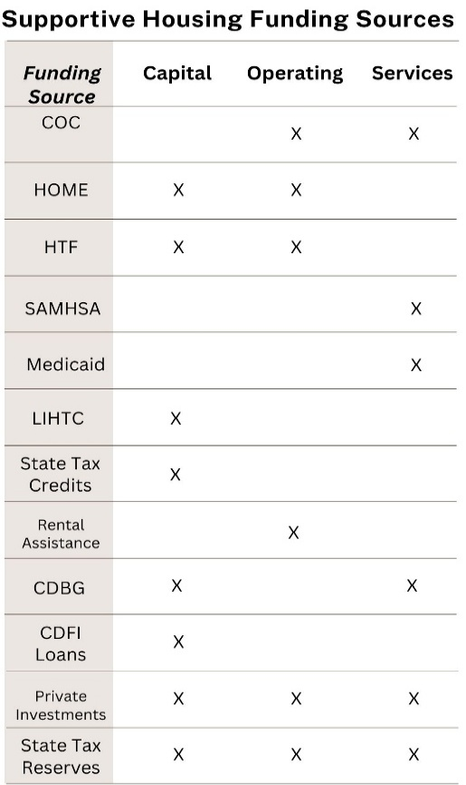
The Supportive Housing Funding Sources Chart (Table 1) illustrates the complex but coordinated landscape of funding that makes supportive housing possible. Federal programs along with state and local funds and private investments play a distinct role in developing and operating supportive housing. While some sources, such as Low-Income Housing Tax Credits (LIHTC), are limited to construction and development, others like the Continuum of Care (CoC) and Medicaid fund the services that are essential to making supportive housing work.
Table 1
Improving access to healthcare, behavioral health services, and tenancy support, primarily funded through Medicaid, is critical for helping people stay housed, reduce emergency system use, and achieve lasting stability. Many supportive housing residents are Medicaid-eligible due to disabilities. Medicaid expansion has been especially helpful in streamlining enrollment for individuals transitioning from homelessness or institutions who may not yet have a formal diagnosis or connection to care.
When supportive housing is implemented with adequate funding, access to services, and based on proven quality standards, it delivers strong outcomes. When those elements are lacking, however, effectiveness declines, leading to higher public costs and poorer results.

Supportive Housing Landscape in [YOUR STATE and DISTRICT IF FOR A REPRESENTATIVE]
► Replace the example below with your own state’s supportive housing story — recent investments, funding mechanisms, or unit-production goals. Keep it to 3–4 sentences.

EXAMPLE: Michigan’s First Congressional District spans the Upper Peninsula and much of northern Lower Michigan, where affordable housing and behavioral health services are limited. In 2024, Michigan appropriated $20 million for its Supportive Services Transformation Fund — building on a 2022 pilot — to fill Medicaid service gaps and expand behavioral health support. The state’s Qualified Allocation Plan sets aside Low-Income Housing Tax Credits for supportive housing, helping the state exceed its goal of 150 new units in 2023 by creating 173 new units.
This progress depends on sustained federal investments from HUD, HHS, and the Treasury, each playing a vital role in developing and maintaining supportive housing in [YOUR STATE]. Federal investments are administered through a combination of state agencies, local governments, and nonprofit partners. The table below highlights critical programs that provide a portion of funding for supportive housing in [YOUR STATE]. with available data on allocations to the state and, where possible, to the [DISTRICT IF FOR A REP].
Federal Resource | Statewide Allocation | Estimated Allocation – MI-1
Low-Income Housing Tax Credits | $27.6 million 9% credit (2024)  Find your state data here | Funding not automatically allocated per district; projects must apply to receive credits
Continuum of Care | $107.7 million (2024)  Find your state data here | $11.3 million (2024)  Find your state data here
HOME Investment Partnership | $45 million (2023)  Find HOME, HCV, CDBG, HTF data by state here. | $1.5 million (2023)  Find HOME, HCV CDBG data by district here
Housing Choice Vouchers | $470 million (2023) | $6.2 million (2023)
Community Development Block Grant | $121 million (2023) | $2.6 million (2023)
Housing Trust Fund | $9 million (2023) | HUD does not publish district-level information
Medicaid | $17.8 billion (2024)  Find your Federal Share of Medicaid here. Select state. Data for federal share is on the top right of page 2. | 21,900 individuals with Medicaid (2024)  Find state data here: individuals with disabilities on Medicaid in the district. Hover over the district and use the data for people with disabilities.
SAMHSA | $200.7 million (2024)  Find SAMHSA funding per state here. On left side of the page, select AWARD FISCAL YEAR 2025, STATE (your state) and click FILTER. Make sure you are on the AWARDS tab and then click DOWNLOAD AWARDS on the right side of the page. Sum the award amount. | $3.35 million (2024)  Find SAMHSA funding per district here.  On left side of the page, select AWARD FISCAL YEAR 2025, STATE (your state), DISTRICT (member's congressional district) and click FILTER. Make sure you are on the AWARDS tab and then click DOWNLOAD AWARDS on the right side of the page. Sum the award amount.

Conclusion
Advancing supportive housing creates a pathway to independence for individuals and more efficient use of public resources. Implemented well, with adequate service funding, it delivers measurable outcomes and reduces spending on emergency services, hospitals, and incarceration. By pairing stable housing with the right support, people with disabilities and complex needs can become more self-reliant and reduce reliance on public systems.

ABOUT [YOUR ORG]
►Replace the CSH boilerplate below with 3–4 sentences about your organization: mission, scale/reach, and a contact person for follow-up.
EXAMPLE: CSH is the national leader in supportive housing. For the past 30 years, we have championed affordable housing paired with essential services like substance use, mental health, and tenancy support, to help people experiencing or at risk of homelessness get into and stay housed. Active in over 300 communities across 48 states, CSH has helped create more than 385,000 homes and generated billions in economic activity. As a certified CDFI, we’ve invested over $1.2 billion in affordable and supportive housing and critical community infrastructure over the past decade. We work with lawmakers and community leaders to advance common-sense, non-partisan policy solutions grounded in evidence and cost-effectiveness to improve housing outcomes nationwide. For more information: Kara Mergl, Director of Policy & Government Affairs (kara.mergl@csh.org)

Analyzing the Cost and Offsets of Denver’s Supportive Housing Program. Available: https://www.urban.org/sites/default/files/publication/104495/analyzing-the-costs-and-offsets-of-denvers-supportive-housing-program_2.pdf
Zillow Research. (2023). Zillow Observed Rent Index (ZORI). Retrieved from https://www.zillow.com/research

